**CEWP MOD3 Networks and Protocols  
Course Project Description**

**W2020**

**Part 1 and 2**

**Description**

The aim of this project is to design and configure an enterprise network according to a set of given requirements, using packet tracer. The enterprise consists of a headquarter (HQ), 3 branches (branch-1, branch-2, and branch-3) and a home office (SOHO). The entire network is presented in figure 1, together with a set of requirements.

You may work in groups of 3 or 4 and the project will require the following:

- Configuring networks   
- Static routing: Specific + Default routes  
- Dynamic routing  
- Wireless access  
- IPv6 on branch 1 AND 2 (At least!)  
- Configuring and testing applications on the internet

You will need to submit a packet tracer file to Moodle. The file should be properly documented. Documentation should include **IP addresses** **of router interfaces and any servers**. You do not have to document the PC addresses as they are assigned via DHCP, except for the manually entered IPv6 PC.

* Deadline: PART 1 Friday, April 10th , 2019 (Midnight)
* Deadline: PART 2. Tuesday, May 12th , 2019 (Midnight)

**Before you submit part 1 or 2 of your project, please go through each of the requirements and check that they have all been done. The best way to do this is have someone else in your group that didn’t work on the same part of the project to verify your work. This way you will not leave anything out and lose marks.**

**Requirements**

**Part 1:**

1. **Building the network.**  
   Create a packet tracer with the network presented in figure 1  
   **Please use ONLY the following Routers: 1921 or 2911**Add for each subnet at least two PCs  
   Assign hostnames for routers with any theme you want but keep the reference part indicated in figure 1. As an example: For a Disney theme, for HQ1 you can rename it as MickeyMouse-HQ1
2. **IPv4 addressing.**  
   - Plan the addressing scheme in the company according to the requirements given below- All PCs should be dynamically configured via DHCP. You can either i) use one DHCP server per subnet or ii) use one DHCP server per branch/headquarter  
   - For Amazon, create a File Server with an appropriate IP address
3. **Configuring routing.**  
   - configure all routers for OSPF routing **EXCEPT** for Branch 3  
   - configure Branch 3 with STATIC routing only. On ISP3, it must also be configured to find the networks on Branch 3 and the information must be shared dynamically with the rest of the network. You can use the command: redistribute static subnets in OSPF to share the static routes with the rest of the OSPF routers.
4. **IPv6 addressing.**  
   - Assign IPv6 addresses on Branch-1 and Branch-2  
   - Assign your own global unicast addressing so that the global routing prefixes are the same but the **subnets** are different  
   - At least one interface on the router must have a manually assigned link local address  
   - Verify that the PCs in all networks in Branch-1 and Branch-2 can reach each other via IPv6, as well as the servers

**REQUIREMENTS for the NETWORKS:**

**Headquarters: 150.50.0.0 1000 subnets**

**Branch Office 1: 170.20.0.0 6 subnets**

**Branch Office 2: 200.1.1.0 13 subnets**

**Branch Office 3: 200.2.1.0 28 hosts**

**SOHO: 192.168.50.0 250 hosts**

**ISPs: 5.0.0.0 use subnets with the least number of hosts possible (for point to point)**

**Amazon 13.225.191.0/24**

**ZONES:**

**Engineering Zone – HQ-1 networks**

**Administration Zone – HQ-2 Networks including Accounting**

**Marketing Zone – BR1**

**Manufacturing Zone – BR2 and BR3**

**SOHO Zone – SOHO**

**Amazon Zone - Amazon**

**Part 2:**

1. **SSH**- Configure SSH for the BR-1 and BR2 routers only. Each router must have a secret enable password on it. **Please indicate the username and password on the Packet Tracer that you use to access ssh.** Also, configure the routers with the “ip ssh version 2” command.
2. HTTP.

* Create an HTTP server for Amazon’s network
* Change the homepage to reflect Amazon’s homepage (Include AMAZON logo, welcome to Amazon, etc.)

1. **DNS.**

* **Please submit Planning DNS for Project.docx file first to make sure your DNS domain and zones will work correctly**
* For each zone in Figure 2 add one server, it will take the role of an HTTP, FTP and email server.
* Create a DNS server in the headquarters network for the entire company network with the appropriate zones for each server as indicated in Figure 2
* Each Server from each of the zones should be reachable via DNS as well as the Amazon Server and anything else you feel is appropriate
* Add a printer in the Administration Zone, and make it reachable via DNS
* Add the 2 ssh routers (BR-1 and BR-2 Company routers) into the DNS

1. **FTP, HTTP, Email for each zone.**

* Use the server in **each zone** as an email server.
* Create a user for the emails required below.
* Choose 4 PCs and give them names as in Figure 2.
* Send an email from sales manager to the HR manager and have him reply back.
* Send an email from manufacturing manager to the IT helpdesk and have him reply back.
* Make the Engineering File Server an FTP server and create a name in DNS to reach it. (Example: [ftp.engineering.disney.ca](ftp://ftp.engineering.disney.ca))
* Create a file in HR manager called “listToFire.txt” and put it on the engineering file server.

1. **WIRELESS**

**SOHO**

* Configure the link between the SOHO router and SOHO wireless router as another subnet in the ISP’s network
* Configure the wireless SOHO router for the following:
  + Give an appropriate SSID name to be used in the SOHO (do not use the default)
  + Use the class C private address 192.168.50.0/24
  + Allow only 20 hosts on the network
  + Make sure that the Network is secure so that no one can get on the wireless network without a password.
  + Use the highest security available.
* Connect at least 1 laptop to the wireless SOHO router and verify that it can reach Amazon

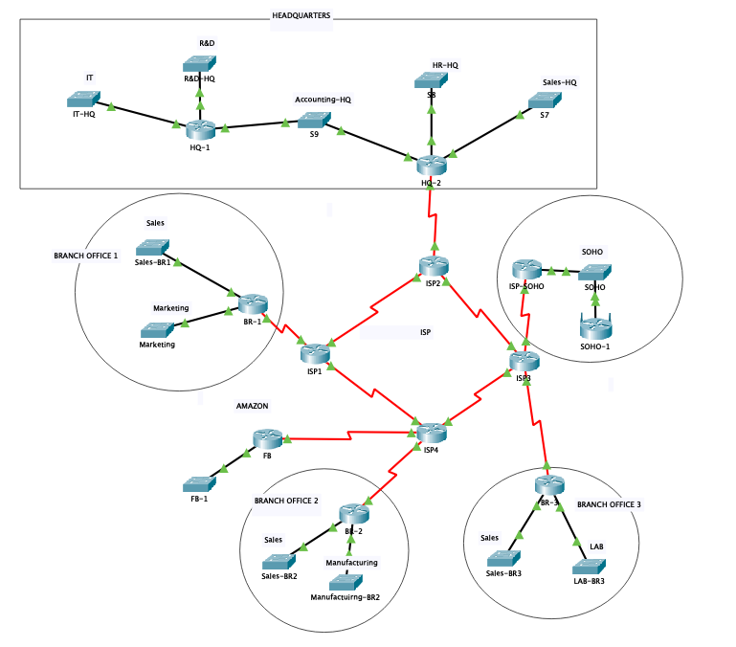

Figure 1: Network topology and requirements

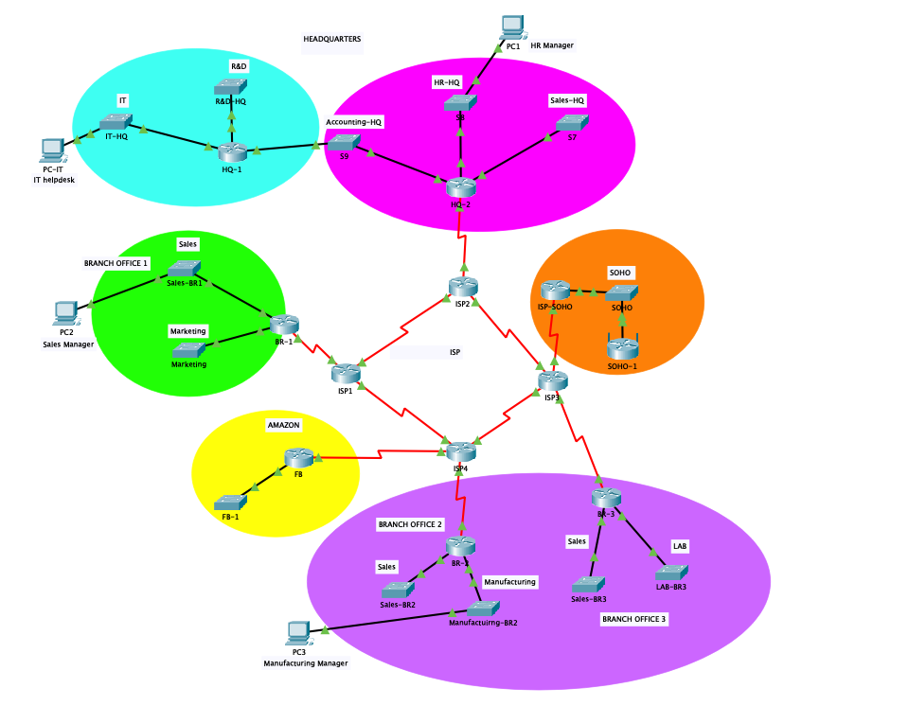

Figure 2: DNS zones